Course: CSN 405 – Network Programming
LAB 9 – AWK

Student name | Phan Ngoc Hanh Nhi
Student ID | 2131209002

Question 1: Student Performance Processing
DATASET: course_score.txt
$1 = student_id
$2 = name
$3 = group
$4 = quiz
$5 = midterm
$6 = final
S001 An K13 8.0 7.5 8.5
S002 Binh K13 6.5 7.0 7.2
S003 Chi K14 9.0 8.5 9.4
S004 Dung K13 5.5 6.2 6.8
S005 Hanh K14 7.8 8.1 8.0
S006 Kiet K15 4.5 5.0 5.5
S007 Linh K15 8.8 9.0 9.1
S008 Minh K14 6.0 6.8 7.0
S009 Nam K13 7.2 7.9 8.1
S010 Oanh K15 9.5 9.2 9.6
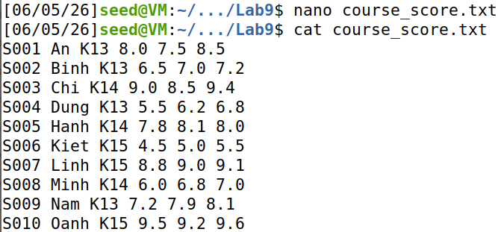
Requirements:
- Print only student ID and student name.
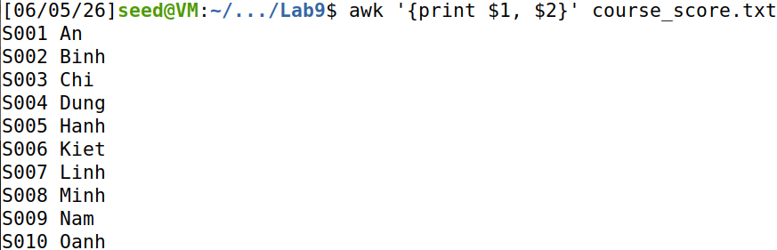
- Print student name, group, and final score.
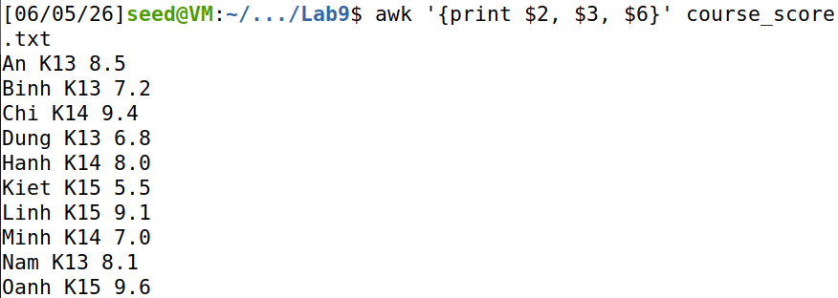
- Print students whose final score is at least 8.0.
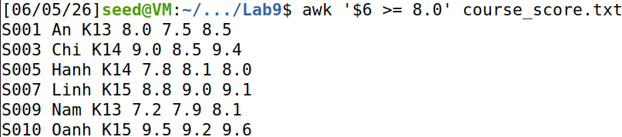
- Print students whose quiz score is below 6.0 or final score is below 6.0.
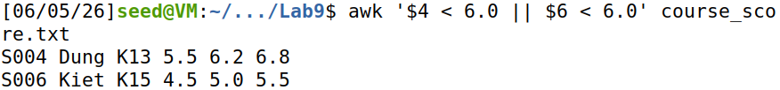
- Print each student with a serial number added as the first output column.
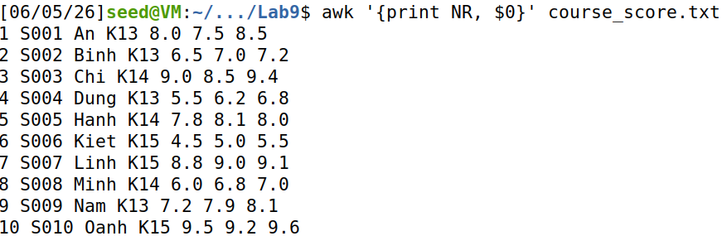
- Calculate each student’s total score using: quiz 20%, midterm 30%, final 50% then print name and total score with 2 decimal places.
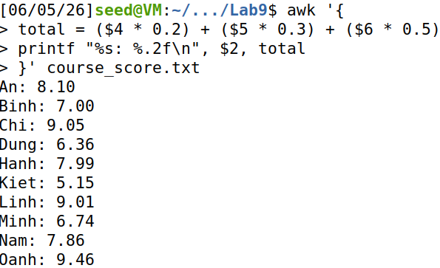
- Calculate the average final score of all students.
- Find the student with the highest total score.
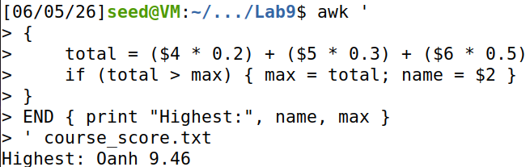
- Count how many students belong to each group.
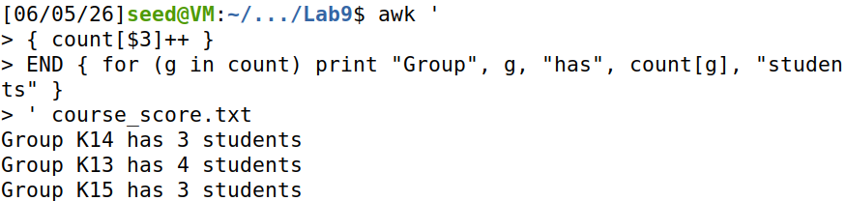
- Print a formatted table with columns: ID, Name, Group, Quiz, Midterm, Final
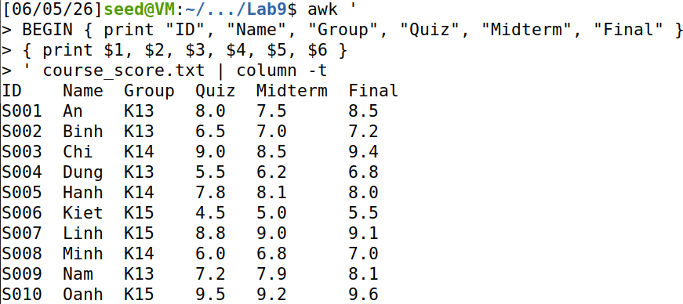
Question 2: CSV Data Processing with Field Separator
DATASET: library_loans.csv
Columns:
$1 = date
$2 = student_id
$3 = department
$4 = book_type
$5 = days_late
$6 = fine_vnd

date,student_id,department,book_type,days_late,fine_vnd
2026-04-01,SV001,CIT,Programming,0,0
2026-04-01,SV002,BBA,Management,3,15000
2026-04-02,SV003,CIT,Networking,5,25000
2026-04-02,SV004,EEE,Circuit,0,0
2026-04-03,SV005,CIT,AI,10,50000
2026-04-03,SV006,BBA,Finance,2,10000
2026-04-04,SV007,CIT,Security,7,35000
2026-04-04,SV008,EEE,Robotics,1,5000
2026-04-05,SV009,BBA,Marketing,0,0
2026-04-05,SV010,CIT,Database,4,20000
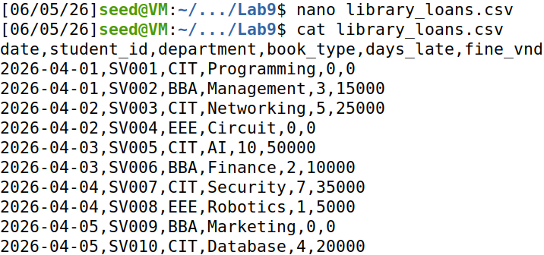
Requirements:
1. Print student_id, department, and fine_vnd. Skip the header row.
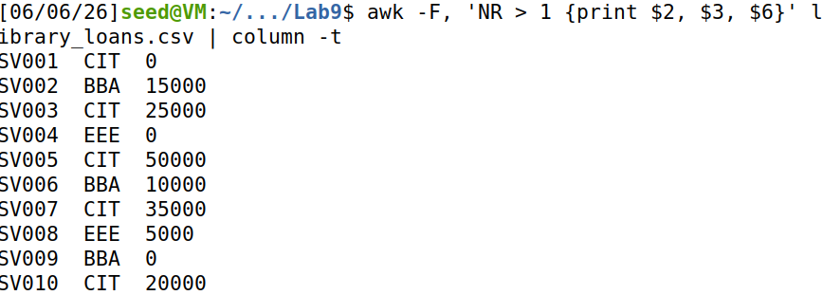
2. Print only overdue records where days_late > 0.
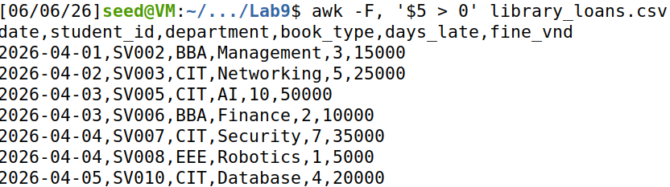
3. Calculate the total fine collected and the average days_late for overdue records.
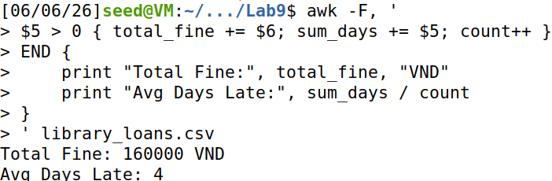
4. Count how many loan records each department has.
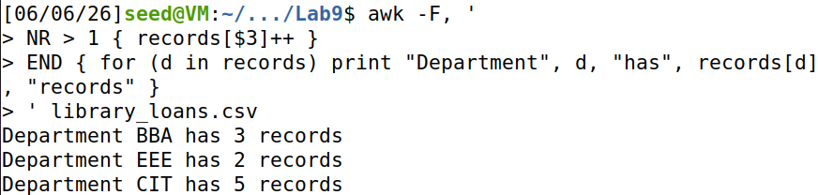
5. Find the student with the highest fine_vnd.
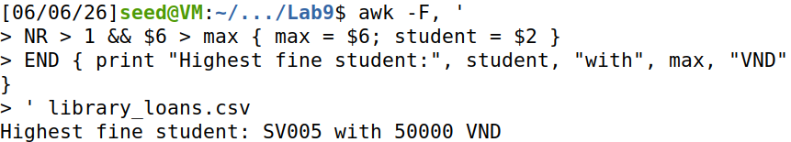
Question 3: Authentication Event Audit
DATASET: auth_events.log
Columns:
$1 = [date
$2 = time]
$3 = user
$4 = IP
$5 = action
$6 = result
[2026-04-10 08:00:01] user1 127.0.0.1 LOGIN SUCCESS
[2026-04-10 08:02:11] user2 192.168.1.10 LOGIN FAIL
[2026-04-10 08:03:15] user2 192.168.1.10 LOGIN FAIL
[2026-04-10 08:04:20] user3 10.0.0.2 LOGIN SUCCESS
[2026-04-10 08:05:01] user2 192.168.1.10 LOGIN FAIL
[2026-04-10 08:06:30] user1 172.16.0.5 LOGOUT SUCCESS
[2026-04-11 09:00:05] user4 10.0.0.3 LOGIN FAIL
[2026-04-11 09:01:18] user4 10.0.0.3 LOGIN SUCCESS
[2026-04-11 09:05:33] user5 192.168.1.20 LOGIN FAIL
[2026-04-11 09:06:44] user5 192.168.1.21 LOGIN FAIL
[2026-04-11 09:07:52] user5 192.168.1.22 LOGIN FAIL
[2026-04-11 09:10:00] user6 127.0.0.1 LOGIN SUCCESS
[2026-03-17 10:02:15] 127.0.0.1 bad INVALID
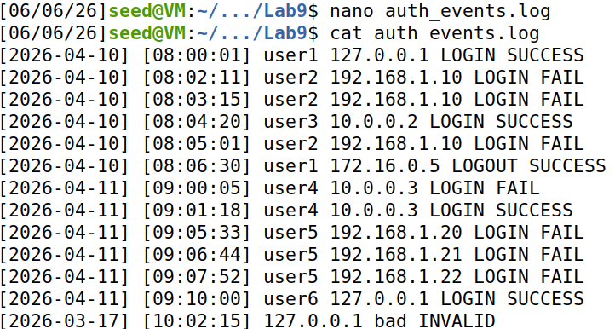
1. Print date, time, user, IP, and result.
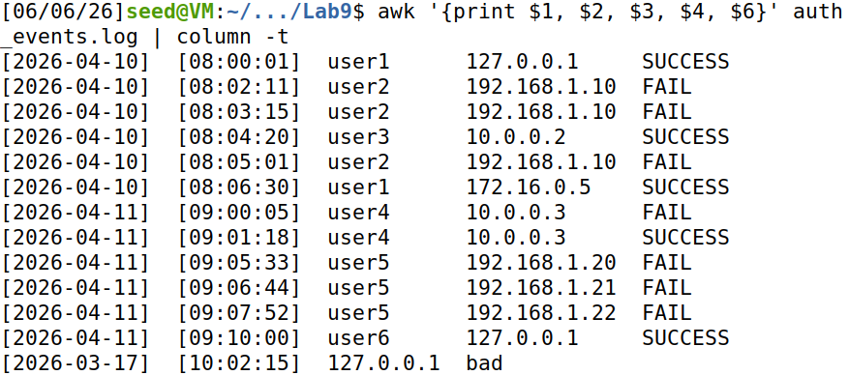
2. Count the total number of authentication events.
3. Count successful LOGIN events and failed LOGIN events separately.
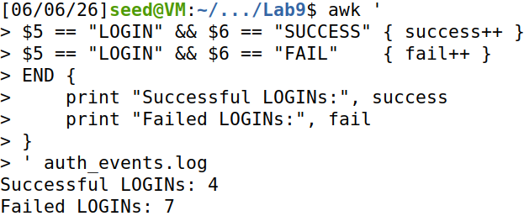
4. Count failed LOGIN events per user and print suspicious users who have at least 3 failed LOGIN events.
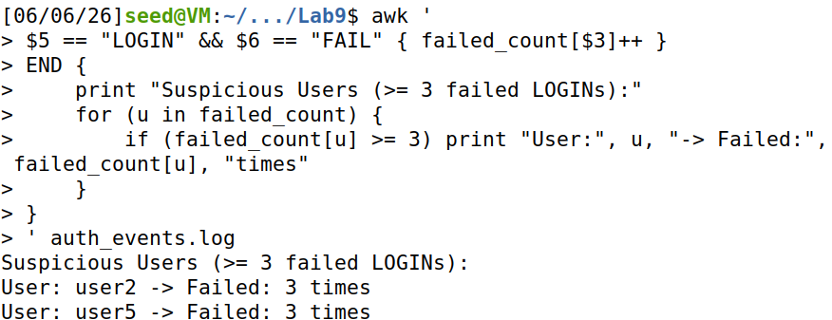
5. Print unique IP addresses that produced failed LOGIN events.
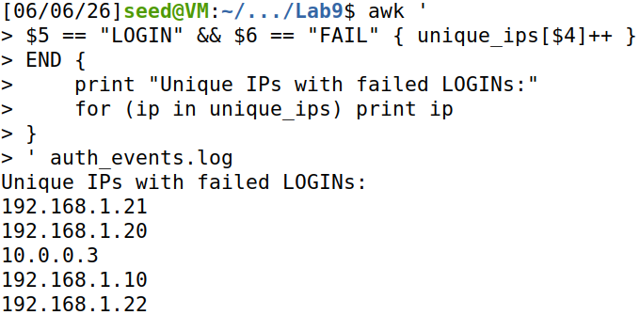
Question 4: Advanced Network Log Audit by Day, IP, and Endpoint
DATASET: network_audit.log
Columns:
$1 = [date
$2 = time]
$3 = IP
$4 = method
$5 = endpoint
$6 = status
$7 = bytes
$8 = latency_ms
[2026-03-18 08:00:01] 127.0.0.1 GET /login 200 512 35
[2026-03-18 08:01:10] 192.168.1.10 POST /login 401 128 45
[2026-03-18 08:02:20] 192.168.1.10 POST /login 401 128 40
[2026-03-18 08:03:15] 10.0.0.2 GET /home 200 2048 60
[2026-03-18 08:04:30] 127.0.0.1 GET /api/users 200 4096 120
[2026-03-18 08:05:45] 10.0.0.3 GET /admin 403 256 55
[2026-03-18 08:06:10] 10.0.0.3 GET /admin 403 256 58
[2026-03-18 08:07:00] 172.16.0.5 POST /upload 500 1024 1500
[2026-03-18 08:08:35] 172.16.0.5 POST /upload INVALID 0 0
[2026-03-19 09:00:01] 127.0.0.1 GET /home 200 1024 30
[2026-03-19 09:01:15] 192.168.1.10 POST /login 200 512 50
[2026-03-19 09:02:20] 10.0.0.2 GET /api/products 200 4096 90
[2026-03-19 09:03:40] 10.0.0.2 GET /api/products 200 4096 85
[2026-03-19 09:04:50] 10.0.0.3 GET /admin 403 256 70
[2026-03-19 09:05:30] 172.16.0.5 POST /upload 500 2048 1800
[2026-03-19 09:06:45] 172.16.0.5 POST /upload 500 2048 1700
[2026-03-19 09:07:10] 192.168.1.20 GET /search 200 1024 110
[2026-03-19 09:08:25] 192.168.1.20 GET /search INVALID 0 0

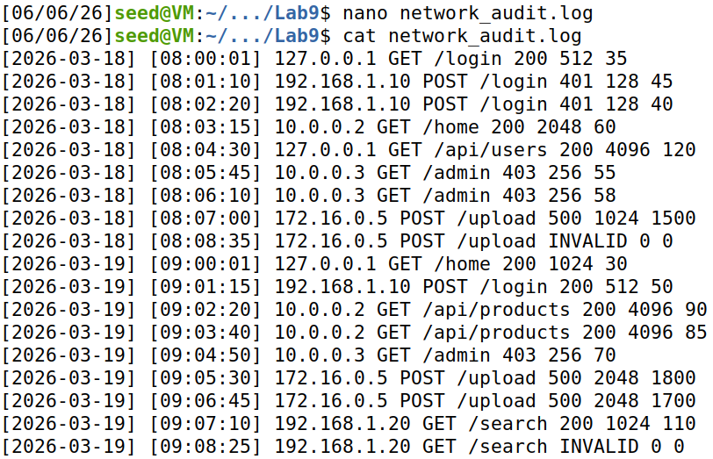
1. Print date, time, IP, endpoint, status, and latency_ms.
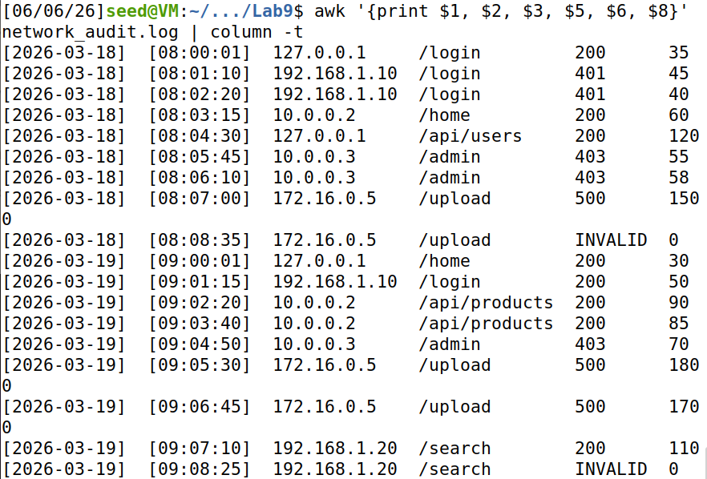
2. Count the total number of log records.
3. Count the total number of requests per day.
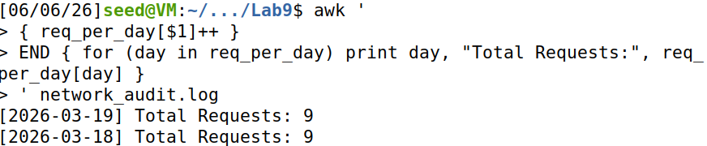
4. Count the number of successful requests per day.
A successful request has status code 200, 201, or 204.
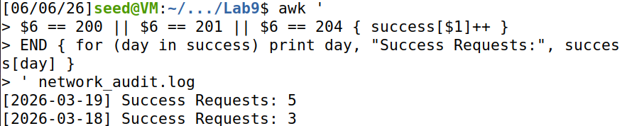
5. Count the number of failed requests per day.
A failed request has status code >= 400 or status = INVALID.
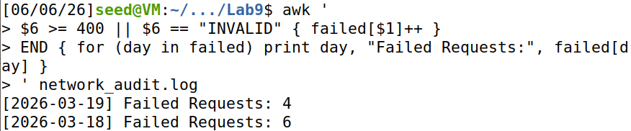
6. Calculate the average latency per day. Only use records where status is numeric.
